

APPLICATION DEVELOPMENT FOR MOBILE DEVICE

COMP1661 – Logbook 1



April 11, 2019

STUDENT: NGUYEN GIA HUY

LECTURER: HOANG DUC QUANG

1. **Basic Information**

|  |  |
| --- | --- |
| 1.1 Student Name | Nguyễn Gia Huy |
| 1.2 Cooperate Students | None |
| 1.3 Exercise | Create a PhoneGap App utilizing the Notification API |
| 1.4 Complete percentage | I have done all the requirements of the excercise |
| 1.5 Brief explanation | My PhoneGap app can allow user to make sound and vibrate notification |

1. **Exercise answer**
   1. **Screen shots for achievements**

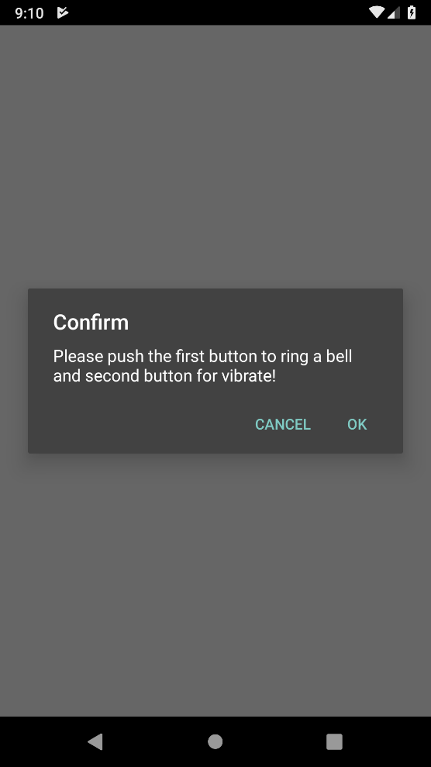

Figure 1: Popup Message

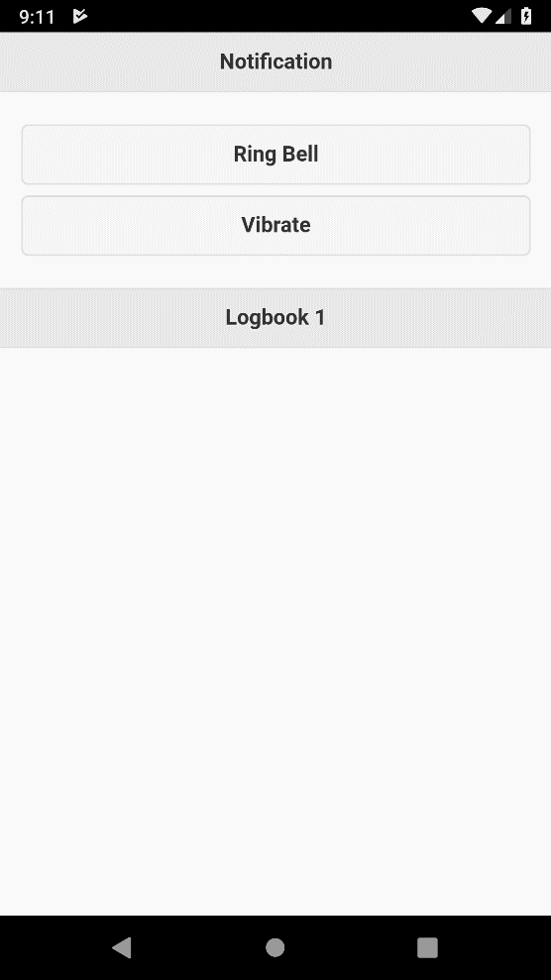

Figure 2: Buttons for activating sound and vibrate notification

* 1. **Code of the application**

HTML

<!DOCTYPE html>

<html lang="en">

<head>

<meta charset="UTF-8">

<meta name="viewport" content="width=device-width, initial-scale=1.0">

<meta http-equiv="X-UA-Compatible" content="ie=edge">

<title>Notification</title>

<link rel="stylesheet" href="http://code.jquery.com/mobile/1.4.5/jquery.mobile-1.4.5.min.css">

<script type="text/javascript" src="http://code.jquery.com/jquery-1.11.3.min.js"></script>

<script type="text/javascript" src="http://code.jquery.com/mobile/1.4.5/jquery.mobile-1.4.5.min.js"></script>

<script type="text/javascript" src="cordova.js"></script>

<script type="text/javascript" src="js/index.js"></script>

</head>

<body>

<div data-role="page" id="home">

<div data-role="header">

<h1>Notification</h1>

</div>

<div data-role="main" class="ui-content">

<a href="#" class="ui-btn ui-corner-all" data-transition="slide" id="btn_sound">Ring Bell</a>

<a href="#" class="ui-btn ui-corner-all" data-transition="slide" id="btn_vibrate">Vibrate</a>

</div>

<div data-role="footer">

<h3>Logbook 1</h3>

</div>

</div>

</body>

</html>

Javascript

$(document).ready(function(){

confirm("Please push the first button to ring a bell and second button for vibrate!");

$('#btn_vibrate').click(function () {

navigator.vibrate(1000);

});

$('#btn_sound').click(function () {

navigator.notification.beep(3);

});

});

Note: These are the original code I have written and copy from Visual Studio Code. These are not images or screen shots.